April 16, 2026

Request for Comment and Notice of Upcoming Zoom Information Session

Improving Physical Integrity and Watershed Security in the Great Lakes Water Quality Agreement

The Great Lakes Ecoregion Network and the Ontario Headwaters Institute request your comments on draft recommendations to Canada and the United States for the improved implementation of the Great Lakes Water Quality Agreement with respect to Physical Integrity and Watershed Security.

The need is pressing for two reasons. First, while over the last fifty years the Agreement has focused multiple efforts on the biological and chemical integrity of the Lakes, there has been less of an effort on physical integrity. As a result, efforts to protect and remediate coastal wetlands and shorelines, as well as to address the negative impacts of dredging and in-stream barriers, lag behind other efforts.

Second, population and development are increasing and projected to continue growing across the Basin. Without the improved integration of land use and watershed planning, these increases can seriously degrade watershed security – healthy and resilient watersheds that protect regional ecological integrity, social wellbeing, and economic vitality.

Our organizations addressed these issues with a draft submission in February to the Great Lakes Executive Committee. That submission was also endorsed by Freshwater Future, which recently provided a small grant to us to solicit broader community engagement.

As a result, we seek your input on the draft recommendations, as follows:

Request for Comments launched April 16
Zoom Information session April 29, 6 pm
Deadline for Comments May 7

See a full version of this and the draft submission here.

To submit comments, get updates, receive a link to the Zoom Information Session, and be invited to endorse the final submission, please send an email to andrew@ontarioheadwaters.ca.

Sincerely yours,

John Jackson Andrew McCammon

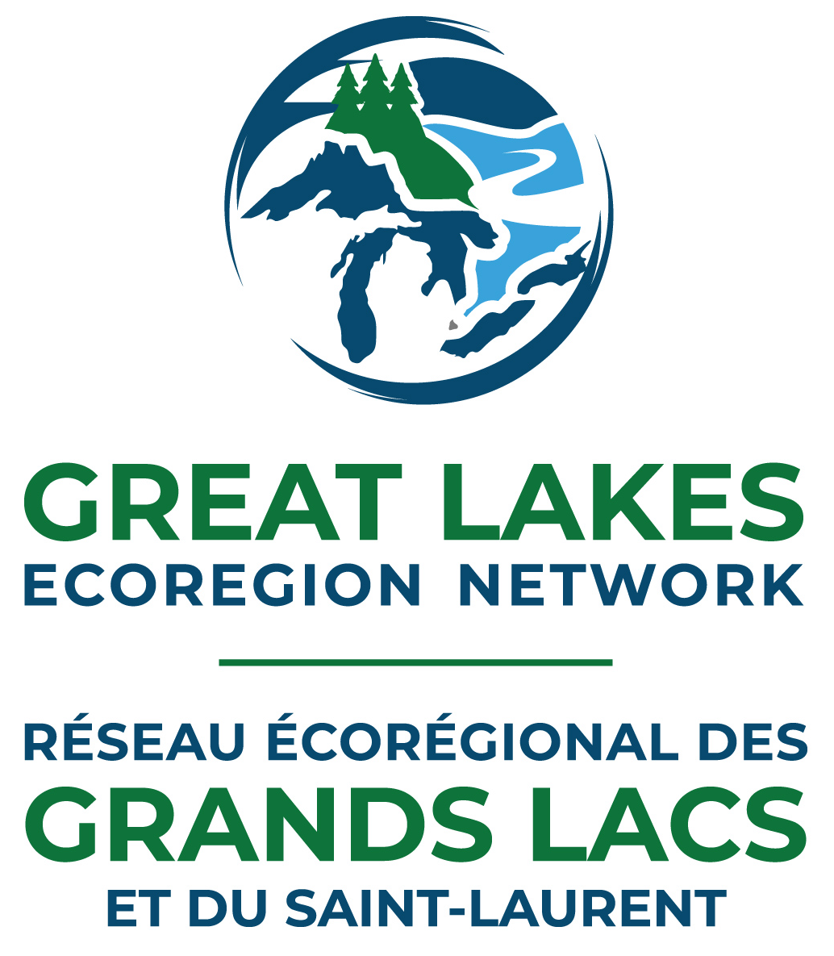

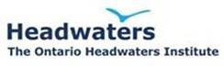

Draft submitted February 2, 2026
Note: Updated to change the due date from May 15 to May 7.

To: Members, Great Lakes Executive Committee, and
Commissioners, The International Joint Commission

c/o GLEC Co-chairs Hiriart-Baer and Seidel, and
IJC Co-chairs Baril and Acker

RE: Improving Physical Integrity and Watershed Security in the Great Lakes Water Quality Agreement

As we approach the Great Lakes Public Forum being held in in Chicago, we are pleased to offer for your consideration draft recommendations [overleaf] on how to improve the implementation of key aspects regarding physical integrity and watershed security in the Great Lakes Water Quality Agreement. The draft recommendations were developed by the groups listed below.

The need is pressing for two reasons. First, while over the last fifty years the Agreement has focused multiple efforts on the biological and chemical integrity of the Lakes, there has been less of an effort on physical integrity. As a result, efforts to protect and remediate coastal wetlands and shorelines, as well as to address the negative impacts of dredging and in-stream barriers, lag behind other efforts.

Second, population and development are increasing and projected to continue growing across the Basin. Without the improved integration of land use and watershed planning, these increases can seriously degrade watershed security – healthy and resilient watersheds that protect regional ecological integrity, social wellbeing, and economic vitality.

In addition, three sections of the recently published State of the Great Lakes 2025 Report highlight the need for greater efforts on physical integrity and watershed security. These are the chapters on Groundwater; Watershed Impacts and Changes in Physical Conditions; and Nutrients and Algae.

Each chapter benchmarks disturbing conditions while a lack of data on the first two result in either no trend or an undetermined trend. This absence of data underscores the isolation of significant science and policy efforts on the Lakes from those on land use planning, occupancy practices, and monitoring.

From now until May 7, we will be seeking input from a range of organizations for final recommendations to be presented to your agencies and others in early June. Naturally, we invite discussion with you and look forward to your comments, via andrew@ontarioheadwaters.ca.

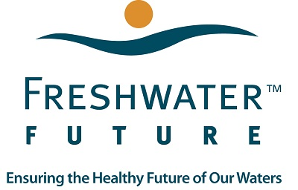
Draft Recommendations: Improving the Implementation of the Great Lakes Water Quality Agreement, Feb 2026
Physical Integrity and Watershed Security in the Great Lakes

Built on the framework of the 1909 Boundary Waters Treaty, the Great Lakes Water Quality Agreement, a bi-national initiative of the United States and Canada, is a visionary document that commits the two nations, separately and collaboratively, to “restore and maintain the chemical, physical, and biological integrity of the Great Lakes basin ecosystem”.
Key accomplishments to date by the US and Canada, known as the Parties to the Agreement, have included the identification and remediation of polluted areas of concern as well as efforts to reduce toxic substances, phosphorus, nutrients, and non-native invasive plants and animals. Most of these accomplishments, however, have been focused on the chemical and biological integrity of the Lakes, while physical integrity has been relatively ignored.
Further, neither the Agreement nor other actions in the US or Canada have adequately pursued watershed security - the long-term protection of healthy and resilient watersheds that protect regional ecological integrity, social wellbeing, and economic vitality - by integrating land use and watershed planning across the Great Lakes Basin.
As a result, and given projected increases in population and development across the region,
we urge the Parties to work collaboratively, with support from the International Joint Commission
and appropriate consultation with rights holders and stakeholders, to better address
physical integrity and watershed security in the Great Lakes Water Quality Agreement.

In particular, we recommend the following commitments:
- Enhancing protection for and the restoration of natural shorelines, vegetated buffer zones, and coastal wetlands;
- Remediating in-stream barriers to native fish migration and those that unacceptably increase thermal loading;
- Adopting guidelines to minimize the adverse impacts of dredging;
- Establishing targets for the retention of key ecological features in a watershed, such as for areas in natural heritage, wetlands, and streamside vegetation, and develop restoration plans where needed;
- Pursuing a better balance on how climate and biodiversity impact the Basin as much as the Lakes,
while also supporting nature-based solutions to address the climate and biodiversity crises;
6. Developing and delivering enhanced outreach and educational programs for physical integrity and watershed
security, including for local decision-makers, to encourage improved stewardship on both public and private
lands; and,
- Recommending that planning authorities integrate land use and watershed planning, either throughout the Agreement and/or or in a new Annex. This could include:
- Taking a whole-of-the-watershed approach, seeking normal flows of clean water entering a municipality from upstream areas while assuring the same for downstream communities;
- Conducting current condition reports to identify, protect, and restore key ecological features and functions, including agricultural lands, to help maintain ecological integrity and regional food security;
- Pursuing pollution prevention for municipal operations with direct impact on water quality, such as storm-water runoff, effluent from treatment plants, and anti-and de-icing practices;
- Embracing sustainable design and development for planning, transportation, energy infrastructure, and buildings; and,
- Performing before and after terrestrial and aquatic monitoring of development and applying adaptive management to address unacceptable outcomes.

Comments welcome via andrew@ontarioheadwaters.ca until May 7, 2026.
Final recommendations to be presented to key agencies in early June.

